Click
Click
Click
Please use this template only and save it in pdf format. We will not edit the submitted file, it will be used for the workshop booklet and the homepage as it is. Please use only one single page, any additional text will not be printed. Citations should be indicated with squared brackets, see Smith and Test. [1]
We only accept pdf files containing one DIN A4 page.
Figures: If you like, you can include figures in your abstract. We recommend to use figures in the size shown below. Please do not use figures larger than 5 cm (1.97 inch) in height. We recommend NOT to use figure captions.
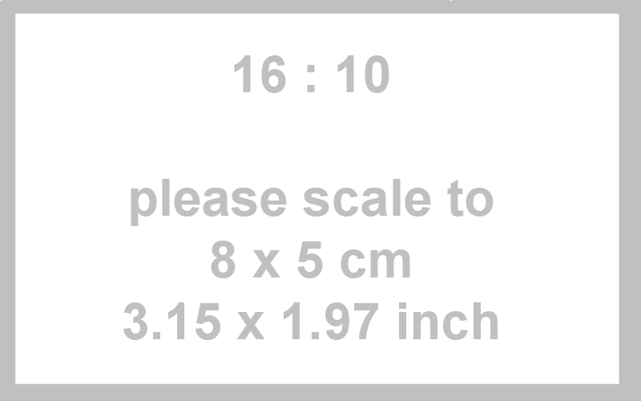
Here comes the abstract text. Here comes the abstract text. Here comes the abstract text. Here comes the abstract text. Here comes the abstract text. Here comes the abstract text. Here comes the abstract text. Here comes the abstract text. Here comes the abstract text. Here comes the abstract text. Here comes the abstract text. Here comes the abstract text. Here comes the abstract text. Here comes the abstract text. Here comes the abstract text. Here comes the abstract text. Here comes the abstract text. Here comes the abstract text. Here comes the citation of Smith and Test. [2] Here comes the abstract text. Here comes the abstract text. Here comes the abstract text. Here comes the abstract text. Here comes the abstract text. Here comes the abstract text. Here comes the abstract text. Here comes the abstract text. Here comes the abstract text. Here comes the abstract text.

[1] B. Smith, W. Test, Journal Name Abbreviation, Year, Volume, fromPage-toPage.
[2] B. Smith, W. Test, Journal Name Abbreviation, Year, Volume, fromPage-toPage.

